**Communication Arts 9**

…………………………………………………………………………………………………………………

2022-2022

U

S

B

A

L

L

S

Y

**Class Overview**

We will be studying World Literature in the form of short stories, poetry, non-fiction, drama, and novels. We will engage in speaking and listening projects based upon the literary readings. This course will heavily focus on writing and include reviews in grammar, vocabulary, and spelling skills. This class will require a heavy amount of reading.

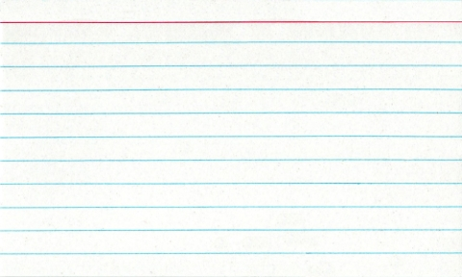

[This Photo](http://en.wikipedia.org/wiki/File:Notecard.jpg) by Unknown Author is licensed under [CC BY-SA](https://creativecommons.org/licenses/by-sa/3.0/)

**Contact Information Require Materials**[kpollari@sidneyps.com](mailto:kpollari@sidneyps.com) *Pencils & Colored Pencils

406-433-2330 *Spiral 5 STAR Notebook – **must be 8.5 x 11**

*Composition Book (College Ruled)

 \***Glue**

\***Scissors**

*Highlighters (red, yellow, green)

*Current Novel

*Reading Text Book

**Academic Dishonesty**

Notebooks are available for purchase from me if needed, but all materials are required as of   
August 18th.



[This Photo](http://commons.wikimedia.org/wiki/File:No_sign_Right.svg) by Unknown Author is licensed under [CC BY-SA](https://creativecommons.org/licenses/by-sa/3.0/)

Academic dishonesty will NOT be tolerated under

any circumstances. Cheating, copying, or plagiarism of any form will result in a zero, and disciplinary referral.

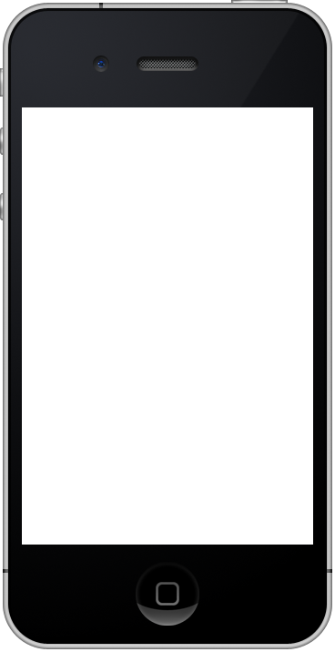

[This Photo](http://apple.stackexchange.com/questions/54326/where-can-i-find-an-iphone-4s-skin-image) by Unknown Author is licensed under [CC BY-SA](https://creativecommons.org/licenses/by-sa/3.0/)

**Technology**  
We will utilize Google Classroom daily. Cell phones are NOT needed for learning in my class and will not be allowed in my classroom during school hours. This includes iWatches.

**Late/ Makeup Work**

All work is posted in Google Classroom. It is your responsibility to complete your assignments from Google Classroom in addition to checking with me for anything that may be added as an enrichment in class. All missing work will be accepted ONLY if you come and visit with me prior to your absence. With this expectation, no more than a 50% can be earned on any late work.